**TAKING MEDICATION**

**VOCABULARY ITEMS**

|  |  |
| --- | --- |
| Capsules  Teaspoon and tablespoon  Inhaler  Heating pad  Lozenge  Caplet  IV drip  Pill  a fever reducer  a cough suppressant  a pain reliever  antacid  steroid  anti-inflammatory | Vitamin  Antibiotic  Diuretic  Sedative  Laxative  Antidepressant  Tablet  Eye drop  Ear drop  Multivitamin tablet  Couch medicine  Injection  Suppository  Ointments |

**EXPRESSION**

This Medication/medicine is….+ name of medication/medicine

Example: This medicine is an antacid

This medicine is for….+name of illness

Example: This medicine/ it is for stomach acid

This medicine is to…..

Example: This medicine is to counteract (neutralize) the acid in your stomach/ to relieve indigestion and heartburn.

**ABOUT MEDICATION**

**Time:** When, how often

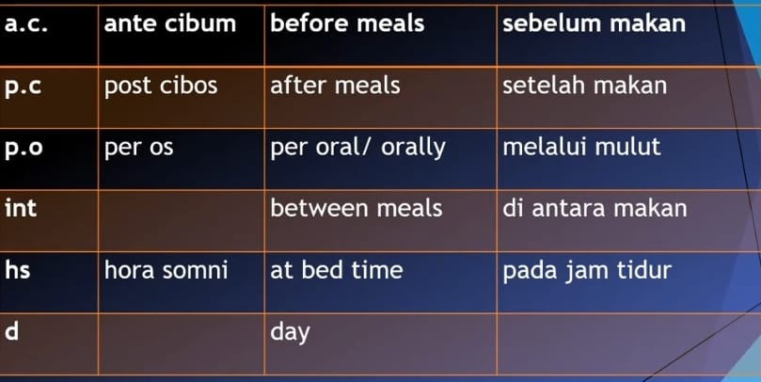

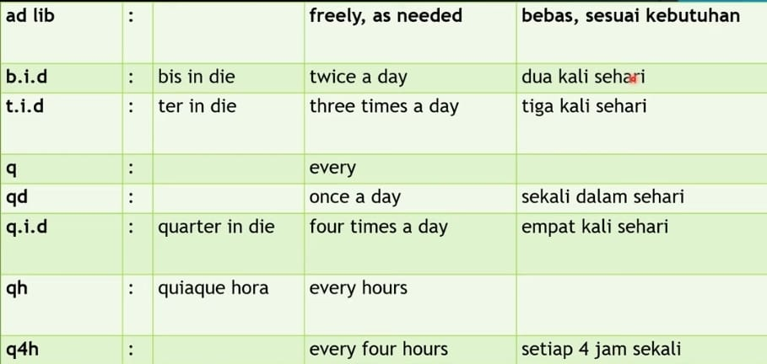

**Route:** How to use

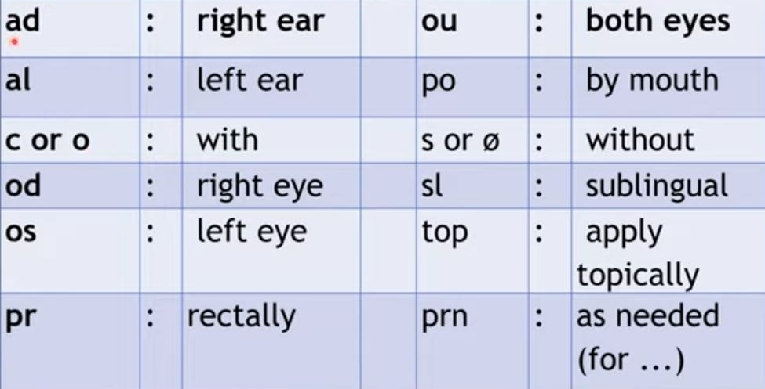

**Dosage:** How much

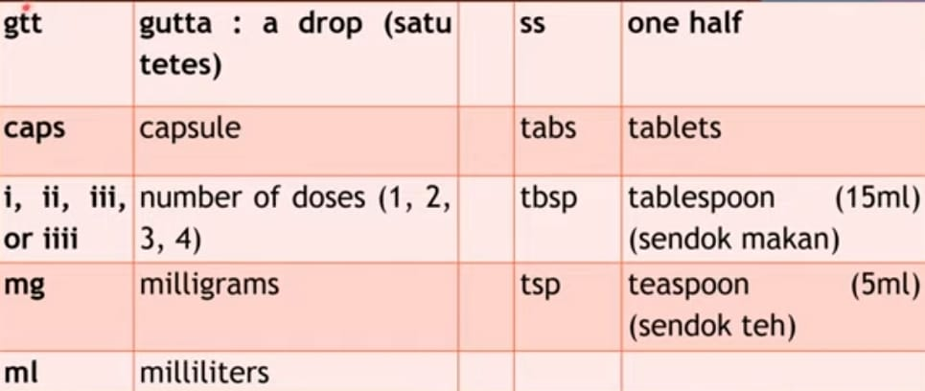

**USING THE EXPRESSION IN OFFERING MEDICATION**

