**YAYASAN PEMBINA PENDIDIKAN INDONESIA (YPPI) WIDYAGAMA**

**SEKOLAH TINGGI ILMU KESEHATAN (STIKES)**

**WIDYAGAMA HUSADA**

**Terakreditasi**

Program Studi : * D3 Kebidanan * S1 Kesehatan Lingkungan * S1 Pendidikan Ners * Profesi Ners



**UJIAN AKHIR SEMESTER**

**BAHASA INGGRIS for ARS**

**Dosen : Anita W. Kursasi, S.Pd, M.Pd**

|  |  |  |  |
| --- | --- | --- | --- |
| Program Studi | : **S1 ARS** | Semester/Tahun | : **Genap / 2025** |
| Hari/Tanggal | : Juni 2025 | Durasi | : 120 menit |
| Nama | : | NIM | : |

1. **READING COMPREHENSION**

**Experience In Hospital**

Last week, I suddenly became very sick and was feeling a great deal of pain on my side. There wasn’t any sign of improvement, so my father rushed me to the emergency room at the nearest hospital. We didn’t feel that we needed to call an ambulance because the hospital is only a few block of from my house.

When we arrived, my dad helped me into the emergency room and the doctor on duty informed me that I had appendicitis. I was immediately admitted to the hospital. A nurse checked my blood pressure, temperature and pulse, while my dad filling out all the necessary paperwork. Soon after, I was prepared for emergency surgery. The surgery did not last that long, but I felt sore afterwards. I was hospitalized. For three days.

In a couple of days, I was back on my feet and I felt very happy. No one likes to visit hospitals, but I’m glad we have them.

1. **Choose TRUE or FALSE based on the reading passage you have read.**
2. T / F The story above is catagorized as a recount text
3. T / F The writer’s father called on ambulance.
4. T / F The writer had appendicitis.
5. T / F The writer had to stay in the hospital for a week.
6. T / F The writer was proud to be hospitalized.
7. T / F The writer’s house is quite closed to the hospital.
8. T / F The writer was given a check up before the surgery.
9. T / F The writer filled out the necessary paperwork before surgery.
10. T / F The writer felt unwell after surgery.
11. T / F ‘ I am glad to have them’ (paragraph 3). the words them refers to the doctors.
12. **GRAMMAR FOCUS: PAST TENSE, Choose the best answer**
13. The patient _______ at the hospital at 10 am, last night.
14. Is arriving b. arrives c. arrived
15. Jen and Tad _______ happy to see me yesterday.
16. Was b.were c.is
17. We _______ call on the ambulance, because it wasn’t necessary.
18. Didn’t called b. didn’t call c. was calling
19. Did you _______ your cold and influenza at the campuss?
20. Catch b. Caught c. catched
21. **CHOOSE THE CORRECT IMPERATIVE SENTENCES**
22. A You need to put your phone away

B Put your phone away

1. A Please, join me in the study

B Could you please join my study?

1. A Don’t open the door unless your parents are at home.

B Don’t open the doors unless your parents are at home.

1. A Asking your lecture about your assignment

B Ask your lecture about your assignment

1. A Complete your report by tomorrow

B Completed your report by tomorrow

**ANZAC BISCUITS**

You will need:

- 2 cups of rolled oats

- 1,5 cups of caster sugar

- 4 tablespoons of golden syrup

- 2 tablespoons of boiling water

- 1 cup of plain flour

- 250 grams of butter

- 1 teaspoon of baking soda

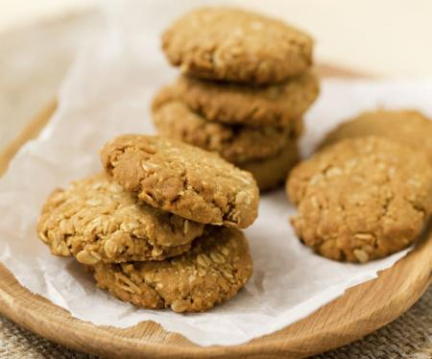

**C1. Circle the correct verb.**

**Steps:**

1. __________ the oven 160-degree C. Turn on / Turn off
2. ________oats, flour and sugar in a large bowl. Mix / Melt
3. ________ butter and golden syrup in a pan. Mix / Melt
4. _____ baking soda and boiling water in a cup. Boil / Mix
5. __________ this mixture to melted butter Cut / Add

and golden syrup.

1. Add this to the oat’s mixture in the large bowl,

_____together well. Stirr / Cook

1. Roll tablespoon full of the mixture into balls. Put / Roll
2. ______ on the tray 5 cm apart Put / Roll
3. ________ lightly on top of each with a fork. Press / Push
4. _________ for 20 minutes. Bake / Fry

**C2. True or False? Write T (True) if the statement is correct and F (False) if it is incorrect based on the text above.**

**T/F**

1. The text above is called narrative text. (………..)
2. The purpose of the text is to tell how to make Anzac Biscuits. (………..)
3. We need more golden syrup than boiling water. (………..)
4. Boiling water is mixed with baking soda. (………..)
5. We use a fork to mix baking soda and boiling water. (………..)
6. We have to put the ball-like mixture on the tray closely. (………..)
7. We need less than 30 minutes to bake the biscuit. (………..)

**D. READING COMPREHENSION**

**Read the following text**

**How to make pencil case**

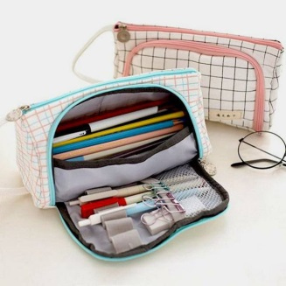Steps:

1. Choose the size you want. If you want to put longer item, such as

a ruler, placed in your pencil case, you ‘ll need a longer pencil case.

2. Find a bag or box that suitable with your choice of size.

It doesn’t have to be nice looking, but strong and clean.

3. Cover the box with paper, any color.

4. Decorate the container. Try some or all of the following ideas. Put on some cool sticker. Decorate with your own art with markers: draw lines, shapes, animals, people, etc.

5. Cut some magazines pictures and stick them on it. Totally cover the box with wrapping paper. Glue on shells, button, or anything else you want to decorate the pencil case with. Add glitter if you like it.

6. Show all your friends and be proud of your unique pencil case.

**Choose the best answer for the following questions.**

1. The length of the pencil case depends on …

a. The item we are going to put there

b. The decoration

c. The size of pen

d. The box that we find

2. The bag or box to make the pencil case should be…

a. Nice looking

b. Longer

c. Strong and clean

d. colorful

3. The following are some ideas to decorate container, except….

a. Put on some cool sticker

b. Draw lines, shapes, animals, people, etc.

c. Add glitter if you like it.

d. Show the pencil case to all your friends.

4. From the text above we can conclude that we have to be ….. in decorating the box to have a good result.

a. box b. careful

c. creative d. risky

5. “………..Add glitter if you like.” (step 4) The synonym of the underlined word is…

a. haze b. be cloud

c. darken d. twinkle