

**YAYASAN PEMBINA PENDIDIKAN INDONESIA (YPPI) WIDYAGAMA**

**SEKOLAH TINGGI ILMU KESEHATAN (STIKES)**

**WIDYAGAMA HUSADA MALANG**

**Terakreditasi Baik**

Program Studi : * DIII Kebidanan * S1 Kesehatan Lingkungan * S1 Administrasi Rumah sakit * Pendidikan Ners *Pendidikan Profesi Bidan

**UJIAN TENGAH SEMESTER**

**BAHASA INGGRIS 3**

**Dosen : Riza Nurhana, S.S, M.Pd**

|  |  |  |  |
| --- | --- | --- | --- |
| Program Studi | : DIII Kebidanan | Semester/TA | : 6 / 2022-2023 |
| Hari/Tanggal | : Jumat/ 24 Februari 2023 | Durasi | : 90 menit |
| Nama | : | NIM | : |

**DIPERKENANKAN MENGGUNAKAN KAMUS**

**Read the following text.**

**ANZAC BISCUITS**

You will need:

- 2 cups of rolled oats

- 1,5 cups of caster sugar

- 4 tablespoons of golden syrup

- 2 tablespoons of boiling water

- 1 cup of plain flour

- 250 grams of butter

- 1 teaspoon of baking soda

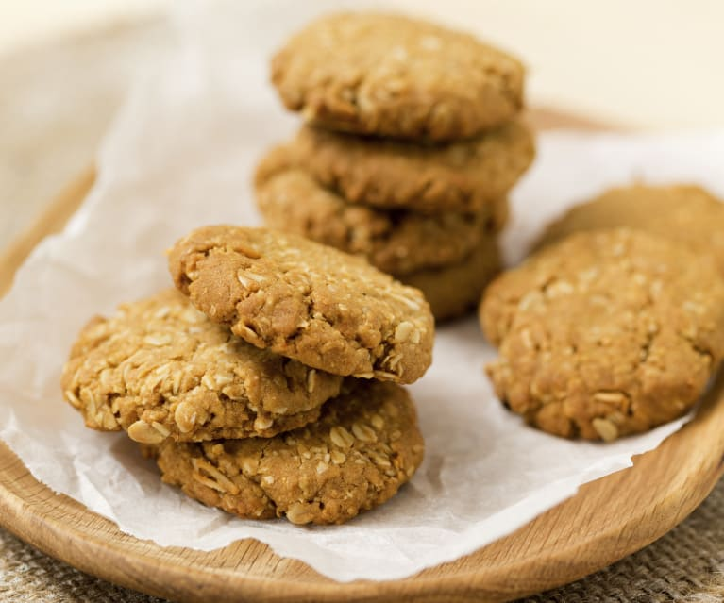

1. **Circle the correct verb.**

Steps:

1. __________ the oven 160 degree C. Turn on / Turn off
2. Lightly grease an oven tray.
3. ________oats, flour and sugar in a large bowl. Mix / Melt
4. ________ butter and golden syrup in a pan. Mix / Melt
5. Mix baking soda and boiling water in a cup.
6. __________ this mixture to melted butter

and golden syrup. Cut / Add

1. Add this to the oats mixture in the large bowl,

_____together well. Mix / Cook

1. Roll tablespoonful of the mixture into balls.
2. ______ on the tray 5 cm apart Put / Roll
3. ________ lightly on top of each with a fork. Press / Push
4. _________ for 20 minutes. Bake / Fry
5. **True or False? Write T (True) if the statement is correct and F (False) if it is incorrect based on the text above.**

**T/F**

1. The text above is called narrative text. (……F…..)
2. The purpose of the text is to tell how to make Anzac Biscuits. (……T…..)
3. We need more golden syrup than boiling water. (……T…..)
4. Boiling water is mixed with baking soda. (……T…..)
5. We use a fork to mix baking soda and boiling water. (……F…..)
6. We have to put the ball-like mixture on the tray closely. (……F…..)
7. We need less than 30 minutes to bake the biscuit. (……T…..)

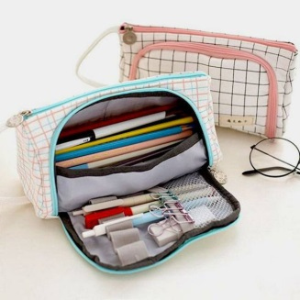**Read the following text**

**How to make pencil case**

Steps:

1. Choose the size you want. If you want to put longer item, such as

a ruler, placed in your pencil case, you ‘ll need a longer pencil case.

2. Find a bag or box that suitable with your choice of size.

It doesn’t have to be nice looking, but strong and clean.

3. Cover the box with paper, any color.

4. Decorate the container. Try some or all of the following ideas. Put on some cool sticker. Decorate with your own art with markers: draw lines, shapes, animals, people, etc.

5. Cut some magazines pictures and stick them on it. Totally cover the box with wrapping paper. Glue on shells, button, or anything else you want to decorate the pencil case with. Add glitter if you like it.

6. Show all your friends and be proud of your unique pencil case.

**C. Find 10 imperative sentences from the text and write them below.**

Example: Choose the size you want.

1._______________________________________________

2._______________________________________________

3._______________________________________________

4._______________________________________________

5._______________________________________________

6._______________________________________________

7._______________________________________________

8._______________________________________________

9._______________________________________________

10.______________________________________________

**D. Choose the best answer for the following questions.**

1. The length of the pencil case depends on …

1. The item we are going to put there
2. The decoration
3. The size of pen
4. The box that we find

2. The bag or box to make the pencil case should be…

1. Nice looking
2. Longer
3. Strong and clean
4. colorful

3. The following are some ideas to decorate container, **except**….

1. Put on some cool sticker
2. Draw lines, shapes, animals, people, etc.
3. Add glitter if you like it.
4. Show the pencil case to all your friends .

4. From the text above we can conclude that we have to be ….. in decorating the box to have a good result.

a.box b. careful

c. creative d. risky

5. “………..Add glitter if you like.” (step 4) The synonym of the underlined word is…

a. haze b. be cloud

c. darken d. twinkle

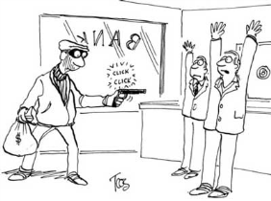

**Bank Robbery**

|  |  |  |  |  |
| --- | --- | --- | --- | --- |
| foot | surrounded | manager | robber | money |
| surrender | gun | officers | door | air |

**E. Complete the story. Use the words in the box.**

Last Friday afternoon, a bank (1) robber **went** to a bank in Los Angeles. He gave the bank teller a canvas bag, pointed a (2) gun at her and said, “Give me the (3) money ! Hurry!”

The teller put the money in the bag, but when the robber turned to leave, the teller pressed a silent alarm button with her (4) foot . The alarm alerted the police.

When the police arrived at the bank, the robber was in the lobby. He was pointing his gun at the bank (5) manager and his assistant. They both had their hands up in the air.

The police (6) surrounded the bank and blocked the front door and

the back door. They trapped the robber inside the bank.

The police captain used a megaphone and told the robber to put down his gun and come out with his hands up in the (7) air . The bank robber said no. He said he would never (8) surrender ___________

While the captain talked to the robber, two (9) officers entered the bank from a secret (10) door . They arrested the bank robber.

**F. Find the past verb (Verb2) Example: went**

|  |  |  |  |  |
| --- | --- | --- | --- | --- |
| 1. | 2. | 3. | 4. | 5. |
| 6. | 7. | 8. | 9. | 10 |